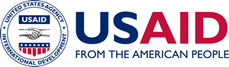

Vetting Language for Issues Letters for Assistance

A Mandatory Reference for ADS Chapter 319

New Edition Date: 01/15/2021
Responsible Office: M/MPBP
File Name: 319mam_011521

The [Applicable] Program Team would insert the following partner vetting statement in all Issues Letters:

The U.S. Agency for International Development (USAID) has determined that any new awards or cost modifications for humanitarian-assistance programs in [applicable location] are subject to partner-vetting. The presumptive recipient is therefore required to submit a USAID Partner Information Form (PIF), USAID Form 500-13, for all of its key individuals within 15 days of technical approval of the proposal. In addition to submitting a PIF on its own behalf, the recipient is required to submit a PIF for each sub-recipient and their key individuals when the recipient anticipates that it will require prior approval for a sub-award, in accordance with Section 200.308(c)(6) of Title 2 of the Code of Federal Regulations [2 CFR 200.308(c)(6)] within 15 days of technical approval of the proposal.

