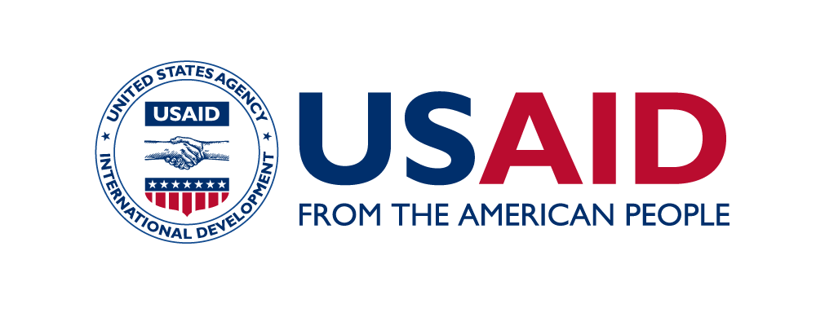
Notes for Drafters
for
Requests for Waiving the Requirements of the U.S. Agency for International Development (USAID) for Branding and Marking under Acquisition and Assistance Awards

Principles:

- In rare instances, Principal Officers may make the determination to waive USAID’s requirements for branding and marking. Chapter 320 of the Automated Directives System (ADS) generally defines a “Principal Officer” as one of the following:

  - The most senior officer in a USAID Operating Unit (OU) in the field (typically a Mission Director, Senior Development Advisor, or Country Representative); or
  - The Senior USAID officer in a regional USAID OU or Washington responsible for a non-presence country.

- In rare circumstances, the Principal Officer may issue a blanket waiver by region or country from the requirements for marking and branding outlined in ADS 320. Prior to issuing such a blanket waiver, the Principal Officer must obtain Administrator concurrence.

- In most cases, the Agency will not approve a request to waive USAID’s requirements for branding and marking if the implementing partner will continue to mark with its own logo and/or identity, especially at field sites. This standard applies to all acquisition and assistance awards, including humanitarian assistance.

- If a Principal Officer approves a waiver, he or she is responsible to ensure that the Mission or OU considers and proposes alternative publicity to ensure that USAID and the American people receive credit for the assistance for which an implementing partner is requesting a waiver.

- All approved waivers are temporary and subject to review by the cognizant Principal Officer at any time. At a minimum, each Principal Officer must review approved waivers every six months from the date of approval to ensure the conditions that justified the initial waiver continue. If conditions have changed, the Principal Officer will evaluate whether to rescind the waiver.

- If a Principal Officer decides to rescind a waiver, the cognizant Contracting Officer/Agreement Officer (CO/AO) is responsible for communicating the decision via email to the implementing partner(s).

- Every six months from the date of an approved waiver, the cognizant Principal Officer will notify the responsible Bureau or Independent Office (B/IO) Assistant Administrator (AA) and the Senior Advisor for Brand-Management in the Bureau for Legislative and Public Affairs (LPA) of the status of the waiver.

- According to ADS Chapter 320, the Principal Officer must consult with the cognizant attorney (Resident Legal Officer or in the Office of the General Counsel) for the OU that is submitting a request for a waiver. In no case may a Principal Officer approve a request for a waiver without clearance from the Senior Advisor for Brand-Management in LPA.

Instructions for Completing the Template:

- Principal Officers should use the following template to submit requests for waivers of the requirements for branding and marking set out in ADS Chapter 320. Information should be brief, substantive, and to the point.

- Once the form is complete, please delete instructional text from the submission.

- Do not include classified materials in unclassified memoranda. If the justification for the request relies upon classified information, please follow the appropriate protocols and reach out to SECinformationSecurity@usaid.gov for questions.

MONTH DD, YYYY

ACTION MEMO: REQUEST FOR WAIVING THE REQUIREMENTS FOR BRANDING AND/OR MARKING OF THE U.S. AGENCY FOR INTERNATIONAL DEVELOPMENT (USAID) [TITLE] [FULL NAME]

FROM: [Bureau/Mission Office]—[Full Name]

SUBJECT: Approval for a Waiver of USAID’s Requirements for Branding and/or Marking for [location or activity or partner]

Recommendation
I recommend that you approve a waiver of the Agency’s requirements for branding and/or marking for [location or activity or partner].

Approve______________ Disapprove______________

Background
[Provide brief background on the requested waiver. Include a clear statement of the problem and its current status, any previous discussions or actions related to it, and the implications of any available options. Include a description of current, specific requirements for [branding and/or marking] and an analysis of why the requirements now cause programmatic or security risks. If this is an extension, please explain why a waiver is still required. Specify which type of award (assistance or acquisition) to which this [Marking and/or Branding] Waiver Request refers].

This waiver is needed for [location or activity] because [compelling political/safety/security concern would cause [marking and/or branding] to have an adverse impact]. The waiver would affect USAID’s [marking and/or branding] in [whole/part], specifically [all materials/certain activities/locations, etc.].

Associated partners [will/will not] continue to use their own [marking and/or branding]. Partners’ continued use of their own [marking and/or branding] [does/does not] clearly reveal that the partners are from the United States or otherwise work with USAID. [For assistance recipients who co-brand with their own logos, provide an explanation if a partner will continue to use its own marking and/or branding. If an implementing partner intends to mark and/or brand with its own logo, the strong presumption is that marking and/or branding with the USAID identity is also required.]
Once a Principal Officer approves a waiver, he or she has the responsibility to provide the approved Action Memo to the cognizant Contracting Officer/Agreement Officer (CO/AO). The CO/AO is then responsible for filing the approved waiver in the Agency Secure Image and Storage Tracking (ASIST) system.
Justification
[Provide an analysis of the context as it pertains to the background and recommendation. If applicable, discuss any opposition and/or support of this waiver of USAID’s requirements for [marking and/or branding], any legislative or other deadlines associated with the decision, any significant Congressional or press attention expected from the decision, and any differences in opinion among U.S. Government Departments and Agencies and their anticipated reaction(s).]

[Describe proposed alternative publicity to ensure that USAID and the American people receive credit for the assistance for which an Agency Operating Unit is seeking a waiver. Missions and Operating Units are required to note here alternative means to supplement the branding and/or marking practices they are proposing to waive, to ensure proper public credit for the assistance provided.]

Authorities
[This paragraph is required for assistance awards only. Delete this paragraph if the request is specific to an acquisition award.] According to Section 700.16 (j) of Title 2 of the Code of Federal Regulations (CFR), “USAID Principal Officers ... may, at any time after award waive in whole or in part the USAID approved Marking Plan, including USAID marking requirements for each USAID funded program, project, activity, public communication or commodity, or in exceptional circumstances may make a waiver by region or country …” if the Principal Officer determines that required marking “would pose compelling political, safety, or security concerns, or marking would have an adverse impact in the cooperating country…. The waiver determination on safety or security grounds must be made in consultation with U.S. Government security personnel if available, and must consider the same information that applies to determinations of the safety and security of U.S. Government employees in the cooperating country.” According to Chapter 320.3.3.3 of the Agency’s Automated Directives System (ADS), the Agency’s Senior Adviser for Brand-Management in the Bureau for Legislative and Public Affairs (LPA) must clear any such waiver determinations. This clearance page for this memorandum documents compliance with this requirement.

[This paragraph is required for acquisition awards only. Delete this paragraph if the request is specific to an assistance award.] Pursuant to ADS Chapter 320.3.2.6 (a), “The USAID Principal Officer has the authority to waive, in whole or in part, USAID marking requirements. The Principal Officer may only exercise this authority if he/she determines that USAID-required markings would pose compelling political, safety, or security concerns, or that marking would have an adverse impact in the cooperating country.” The Principal Officer must consult with the cognizant Assistant Administrator, Contract or Agreement Officer, Resident Legal Officer (RLO) or the Office of the USAID General Counsel (GC) and seek clearance from the Senior Advisor for Brand-Management in LPA (see ADS Chapter 320.3.2.6) before approving or denying a waiver. The waiver must consider the same information that applies to determinations of the safety and security of U.S. Government employees in the partner country.

According to ADS Chapter 320, as the Principal Officer in [B/IO, Mission, etc.], you have the authority to waive, in whole or in part, USAID’s marking and/or branding requirements for a given grants, cooperative agreement, contract, or other instrument when they would be impractical for compelling political, safety, or security concerns, or that marking and/or branding would have an adverse reaction in the partner country at any time after award. Note that the Administrator must concur with the Principal Officer’s decision to issue a blanket waiver by region or country of the requirements for marking and branding outlined in ADS Chapter 320.

As stated in Section 700.16(j) of Title 2 of the CFR § and ADS Chapter 320, approved waivers are not limited in duration, but are subject to review by the cognizant Principal Officer at any time because of changed circumstances. Approved waivers “flow down” to recipients of sub-awards unless specified otherwise. Waivers should continue only if current conditions so mandate; Principal Officers should rescind waivers as soon as circumstances allow.

Resource Implications [required section]
At least every six months, the Principal Officer must review this waiver and notify cognizant Regional/Technical Bureaus and the Senior Advisor for Brand-Management in LPA of the status of the waivers in a Note to the File to be included in ASIST. (See the ASIST filing guidance.).

[State whether the recommendation has any budgetary and/or staffing implications and, if so, the amount and source of funding or staffing required. Obtain clearance from the Bureau for Management (M) for Operating Expense (OE) funds and clearance from the Office of Budget and Resource-Management (BRM) for Program funds. Obtain clearance from the Office of Human Capital and Talent Management (HCTM) for staffing requirements. Clearance by GC is required on all legal issues, and clearance from the Bureau for Legislative and Public Affairs (LPA) is required for issues that pertain to Congress, legislation, and the press. When in doubt, seek clearance.]

Attachment: (When only one attachment)
Document Title [e.g., Background Information, published article from external source, etc.] (If there is only one attachment, provide the name of the attachment here, but do not label it “Tab 1.”)

Attachments: (When multiple attachments)
Tab 1—Document Title
Tab 2—Additional Document
CLEARANCE PAGE FOR ACTION MEMO FOR Marking Waiver Request For

Drafter: [Bureau or IO/Title] [Name] [Phone extension] [After Hours Phone No.]
Approved: [Bureau or IO/Title] [JDoe]

Clearance Clearance Status Date
[Bureau/IO] Title/Name Clear/Info MM/DD/YYYY

Required Clearance
LPA/Senior Advisor for Brand Management

Info
AA
CO/AO
Cognizant RLO or USAID/GC Attorney
RSO or Country Emergency Action Committee (if available/applicable)

