Madagascar FFP development programs use a multi-sector approach to address malnutrition. Over 20 different activities are implemented at the community level and can be grouped into 3 components: Health and Nutrition, Agriculture and Livelihood and Disaster Mitigation and Preparedness. Cross-cutting themes include: Women empowerment and Governance.
Food For Peace activities

WHAT’S GOING ON IN A COMMUNITY/FOKONTANY?

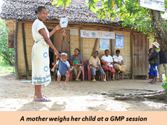 | Growth Monitoring and Promotion (GMP) – Early detection of malnutrition is essential to ensure healthy physical and cognitive development. The purpose of GMP activities is to prevent growth retardation through early detection of growth faltering.
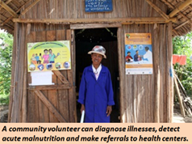 | Community Health Clinic Referrals – Community volunteers identify children with acute malnutrition and refer them to Community Health Clinics. These clinics are the lowest level of formal health facility and provide treatment for diseases and therapeutic nutritional care for children. The purpose of the volunteer referral approach is to ensure children receive the professional medical care that only a clinic can provide.
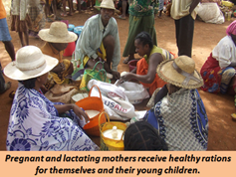 | Supplementary Feeding – Food for Peace provides rations to pregnant and lactating women and children under the age of two. Both food imported from the U.S. and food bought locally with vouchers promote the consumption of a diverse and nutrient-rich diet. The purpose of this activity is to prevent malnutrition among mothers and children during the first 1,000 days (from conception to two years of age) when deficiencies can cause permanent damage to infant physical and mental development.
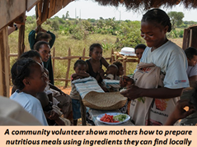 | Cooking Demonstrations are organized by community health volunteers to promote sustainable, balanced dietary practices using local foods, while providing parents with more choices towards a healthy diet. The purpose of these demonstrations is to help mothers learn how to prepare nutritionally balanced dishes using ingredients that are locally available.
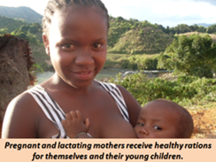 | Promotion of Essential Nutrition Actions (ENA): Community health volunteers visit households to promote nutrition practices that target pregnant and lactating mothers and children under two years old. Activities in farming, sanitation, hygiene and household savings all enable a family to improve its intake of nutritious foods. The purpose of ENA activities is to improve maternal and child health and nutrition.
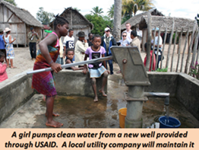 | Water, Sanitation and Hygiene (WASH): These activities work with private utility companies to build clean water systems and sanitation structures communities can afford. Community health volunteers and local leaders also promote good hygiene and sanitation practices, including a “Community-Led Total Sanitation” campaign to promote the use of latrines. The purpose of WASH activities is to provide households with access to quality water and sanitation, and to utilize them properly, to avoid water-borne diseases.
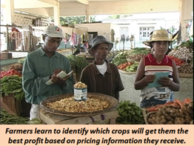 | Agribusiness – Food for Peace helps farmers access agricultural supplies and market information. Farmers also receive training on basic financial and marketing skills that are critical to sustain production and promote sales. The purpose of agribusiness activities is to build the capacity of farmers associations to create a profitable business.
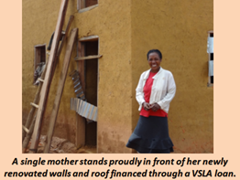 | Village Savings Loan Associations (VSLA) – Groups of up to 20 villagers pool weekly savings and create a peer-managed loan system. After about a year, profits the savings and interest are distributed back to members and also fund small projects that benefit the entire community. The purpose of a VSLA is to provide simple savings and loan facilities in communities that do not have easy access to formal financial services.
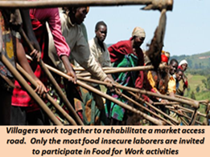 | Food For Work (FFW)– Community members work together on simple infrastructure projects, such as rehabilitating roads and irrigation canals, which directly improve their ability to farm and get their products to market. Volunteers are paid in food vouchers or rations that are the equivalent value of a daily wage for manual labor. The purpose of FFW is to provide the most vulnerable households with food during the lean season and to build productive assets for the community.
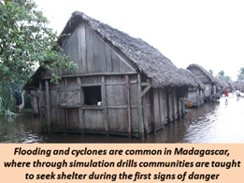 | Disaster Preparedness – Food for Peace works with local leaders to develop disaster preparedness plans, conduct emergency drills and build up landscapes and infrastructure to mitigate the effects of erosion and natural disasters. The purpose of the disaster preparedness activities is to provide the communities the means they need to be more resilient in the face of recurrent natural disasters.

