Energy Market Reforms Brighten North Macedonia’s Future
At the core of a country’s journey to self-reliance, energy security is fundamental for progress. North Macedonia has come a long way since independence in 1991, establishing itself as a free-market democracy. More recently, energy reforms position the country for greater energy security.
Energy reforms began in late 2017, when the USAID Development of Regional Energy Markets (D-REM) supported the Government of North Macedonia to draft the new energy law. The Energy Law was adopted in May 2018, and subsequently, over 50 associated by-laws launched reforms in the energy market, fully harmonizing the country’s energy legislation with European Union (EU) regulations and Energy Community (EnC) requirements based on principles of competition, transparency, and non-discrimination.

New energy legislation introduced many novelties. Most importantly it provided legal grounds for full liberalization of the energy market. As of January 1, 2019, all businesses in the country, including micro- and small- businesses are eligible to purchase electricity on the open energy market at prices 30% lower than they were previously paying. Private sector savings on energy bills enables investments in new technologies and product development and enhances its competitiveness on regional markets.

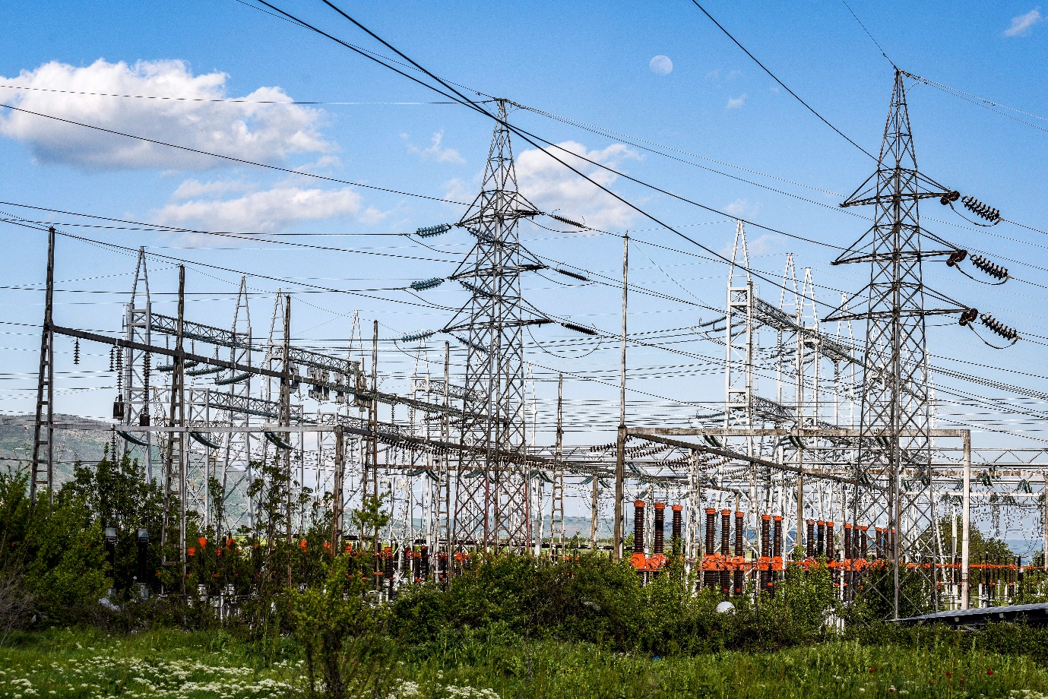
Electricity transformer and power transmission line in Skopje, North Macedonia

Another novelty is the introduction of the universal electricity supplier. North Macedonia is the first country in the Energy Community that selected the universal service provider through an open, transparent, and competitive tendering procedure. With the assistance from the USAID D-REM Project, all necessary by-laws and documents were drafted to establish the universal electricity supplier. A consortium of two electricity suppliers won the competitive tender and commenced with provision of service in 2019.

The universal supplier is mostly beneficial to households, especially those living in remote areas, by providing them with energy security and access to quality electricity services at prices regulated by the country’s energy regulatory body – the Energy Regulatory Commission (ERC). This service also protects households from excessive electricity price fluctuations on the open energy market or electricity price shocks. ERC is using a tariff system in calculating and approving electricity prices offered by the universal electricity supplier. The ERC takes into account social and economic factors to ensure that electricity services are affordable to all households, including lower income and vulnerable consumers.

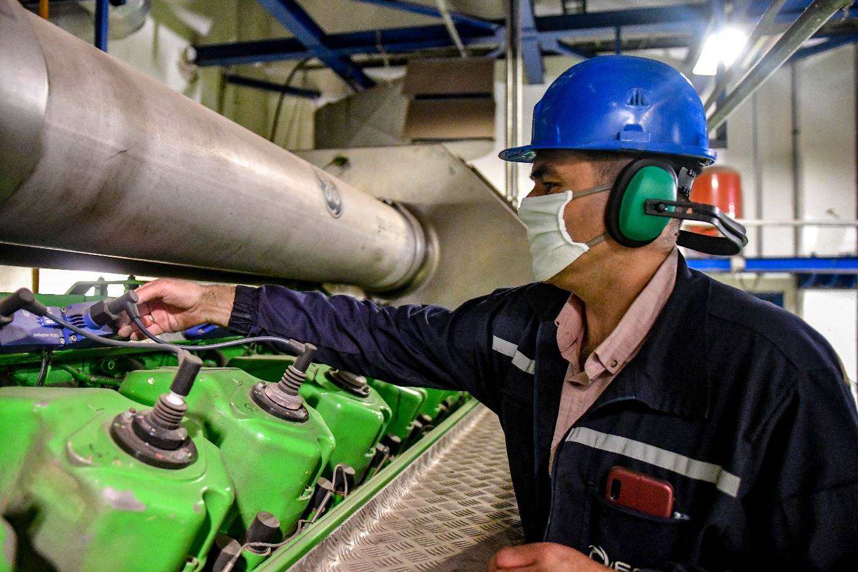
Elektrani of North Macedonia (ESM) employee at a cogeneration power plant in Skopje, North Macedonia

Other reforms aimed to increase investment in renewable energy sources. The USAID D-REM Project assisted in drafting of a set of by-laws to spur investment in renewables, particularly solar energy. One novel reform is the introduction of premiums – a new market-based incentive scheme for private investors in renewable energy; premiums provide investors with a fixed premium on top of revenues from selling electricity on the open market.

Premiums are a significant shift from the feed-in tariffs that were applied previously. Feed-in tariffs proved to be expensive for end users, and the amount of electricity produced was modest. A total of 17 MW of photovoltaics were installed over a seven year period under feed-in tariffs. These electricity generation plants produced only 23 GWh of electricity in 2019, at a cost of 4.6 million euros for end users.

Premiums, on the other hand, are much less costly for consumers. Currently, two tenders are being completed for 62 MW of photovoltaic plants to be installed on state-owned and private land. The first tender for 35 MW photovoltaics on state land was recently completed with great success, using reverse auctions. Most of the investors did not request premiums but were competing on the amount they will pay as a one-time fee to gain the right to install photovoltaic plants on these state-owned land plots. The government collected a total of 2.7 million euros, and these photovoltaic plants are projected to generate over 80 GWh of electricity annually, at no additional cost to electricity users. With this new energy capacity, North Macedonia is better positioned to achieve its renewable energy target.

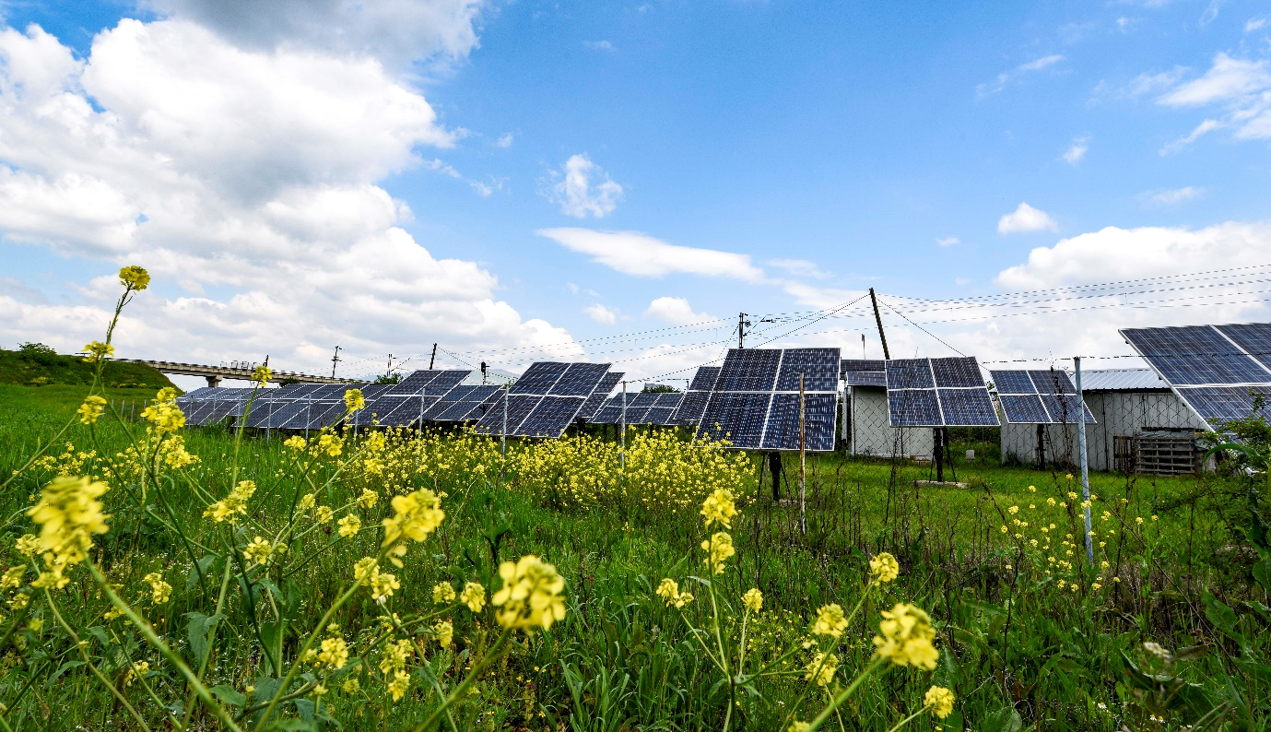
Photovoltaic field in the vicinity of Skopje, North Macedonia
“Development of the energy sector is high on the agenda of the government, especially over the last three years with many needed pieces of legislation adopted, including the Strategy for Energy Development until 2040 in line with EU energy and climate policies. The government is dedicated to energy reforms, not only because they are a crucial requirement for the country’s EU accession, but also to improve the quality of services to energy consumers. This will be achieved by diversifying energy generation and supply, and strengthening the capacity and resilience of the energy sector. The introduction of premiums for renewable energy generation, specifically solar energy, is proving to be one of the most successful undertakings under the new energy law. The country will add 80 GWh annual production of renewable energy within the next year, and this is only the beginning. With the adoption of the Energy law and the framework of renewable energy bylaws developed in close collaboration with the USAID D-REM project, experts predict that the opportunities for renewable energy investment in the future are far greater and wide open”- said Viktor Andonov, Special Advisor for Energy to the Deputy Prime Minister for Economic Affairs.
In order to ensure that all renewable energy generated is absorbed in the electricity market and made available to households and businesses, the government introduced another novelty - an off-taker mechanism. The off-taker is an electricity supplier/trader that has the contractual obligation to purchase the electricity from renewable energy producers if they are not able to sell on the free electricity market. The off-taker will start operations later in 2020, when the contracted renewable energy producers are expected to begin to generate electricity.

Another key USAID partner in this endeavor is the Energy Regulatory Commission (ERC), the country’s energy regulator. USAID’s D-REM Project supported ERC employees to develop over 30 by-laws that made possible many of the novelties introduced in support of the energy market. These accomplishments were recognized regionally, when the Energy Community ranked North Macedonia’s energy regulatory body as ‘number one’, and ERC president Marko Bislimoski was elected president of the Energy Community Regulatory Board in 2019. ERC, in collaboration with USAID and NARUC – the National Association of Regulatory Utility Commissioners, developed a specialized web site www.switch.mk that provides information and real-time calculations on the cost of electricity purchased from different electricity traders and suppliers in the country. This makes easier to electricity consumers both industry and households to pick the supplier that is most appropriate to their specific needs.
"ERC has been mobilized at full capacity over the last two years in order to develop and implement all energy reforms aiming to bring benefits to citizens of North Macedonia and to the industry. We liberalized the electricity market, provided transparent information on all electricity suppliers market offers and implemented all these changes without any disruptions in the electricity supply and the quality of services. The technical assistance that we received from the USAID D-REM project was critical for timely implementation of these novelties prescribed under the new Energy Law. This joint cooperation between ERC and USAID was acknowledged by the Energy Community which awarded us the Best Regulatory Commission for a second year in a row, which makes me personally very proud” – said Marko Bislimoski, President of the North Macedonia Energy Regulatory Commission.
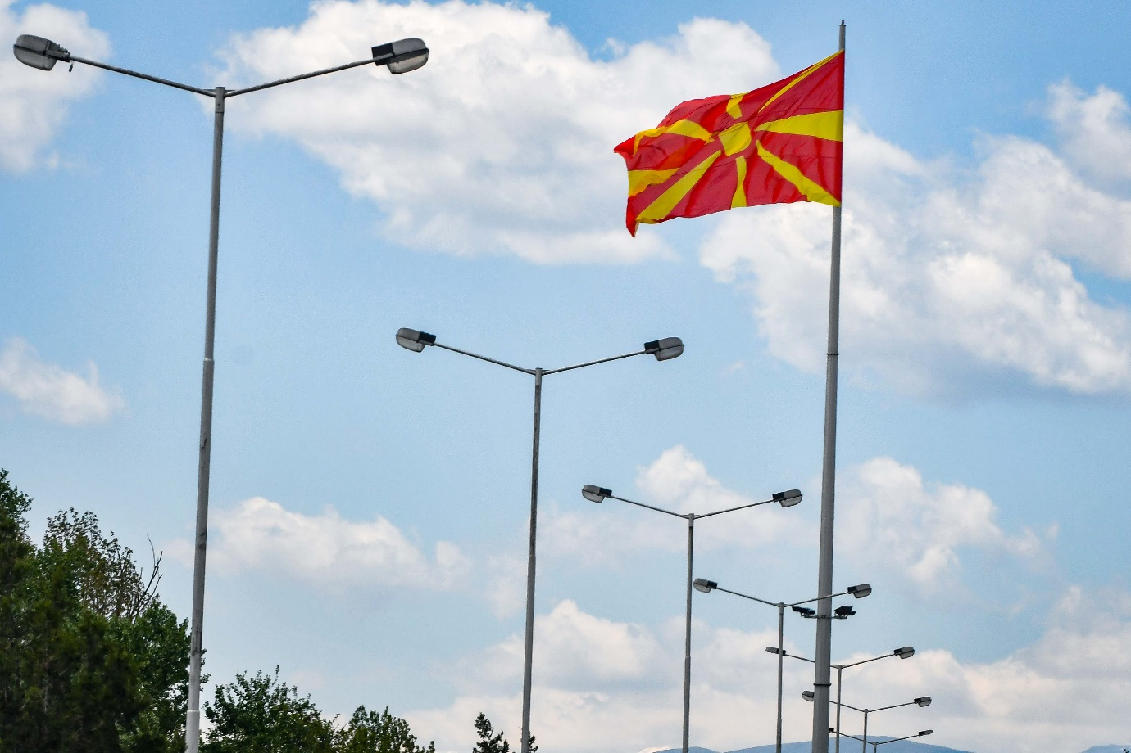
North Macedonia flag waiving over highway light posts
Energy reforms required major changes in the electricity market, including completing all pre-requisites for founding an electricity exchange. Another new entity - the National Electricity Market Operator of North Macedonia (MEMO) was established. The USAID D-REM Project, supported the government to develop by-laws needed to introduce MEMO, which is tasked with establishing the country’s electricity exchange and market coupling with neighboring countries. This will fully integrate North Macedonia’s electricity market with regional markets, thus increasing energy stability through increased competition and transparency, diversified energy generation, increased economies of scale, and decreased market power of individual market participants. MEMO was recognized internationally when it joined the European Association of Energy Exchanges (EUROPEX) as an associate member in 2019.
USAID is pleased to partner with national institutions in their efforts to implement energy reforms; their initiatives have increased generation of electricity from renewable energy sources and diversified the energy portfolio, enhancing the country’s energy security and self-reliance. Strong commitment to reforming the energy sector, and impressive progress to date, earned the country recognition as a “champion” in energy reforms in the region.

