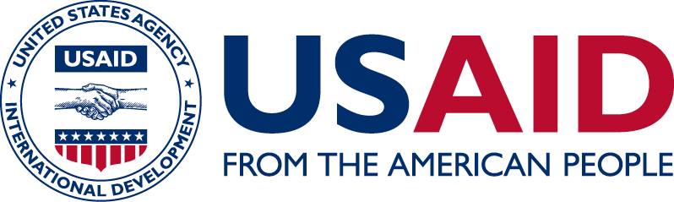
VectorWorks
  - December 2015 – September 2018
  - Total Funding: $1.5 million

VectorWorks is a global malaria prevention project, funded by the President’s Malaria Initiative (PMI). The purpose of the VectorWorks project is to support countries to achieve and maintain high levels of coverage and use of insecticide-treated mosquito nets (ITNs) as well as to facilitate the adoption of proven alternative vector management interventions, including those targeting specific sites or populations. VectorWorks activities in Angola focus on working with Angola National Malaria Control Program (NMCP) to review and modify ITNs distribution strategies employed in the country as well as supporting NMCP preparing and conducting a mass ITNs distribution campaign and through a team of local and international consultants with expertise in communications, logistics, and planning and implementation of mass ITNs campaigns.

ACTIVITIES

Insecticide-treated mosquito nets Strategy Support: review of the Insecticide-treated mosquito nets strategy in Angola

Technical Assistance for Mass ITN Campaign: supports the NMCP and implementing partners to plan and implement a mass ITN distribution campaign

Process evaluation for mass ITN campaign: conduct a process evaluation of the first phase of the mass itn campaign which analyze how well implementation plans were followed and inform further phases of the implementation

ACCOMPLISHMENTS

- Production of the revised ITN strategy (Strategic and Implementation Approach)

- Supported the National Malaria Control program in developing a social and behavior change communication strategy and training materials for the mass distribution bed net campaign; messaging focused on promoting the continued use and care for long lasting bed nets

- Creation of a well-coordinated activities plans; revision and development of training and data collection tools; and strengthening coordinating mechanisms, such as subcommittee

- Produce a Communication plan and review the Social Behavior Communication Change (SBCC) and related training materials

Date: November 2017
E-mail: info.usaid.angola@usaid.gov
Web: http://www.usaid.gov/angola

