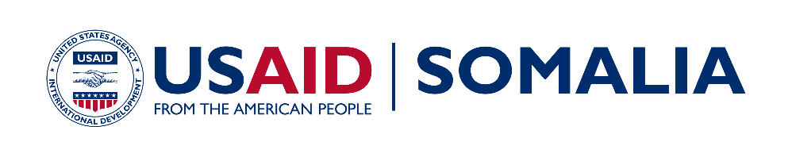
Bringing Unity, Integrity and Legitimacy to
Democracy (BUILD)

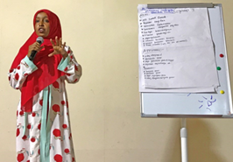  Participant presents findings from the Women Electoral Representation Workshop  Funding Level:  $31.5 million  Duration:  March 2016 – March 2021  Activity Goals:  - Increased participation and trust in political processes among citizens  - Greater integrity, accountability, and transparency in electoral processes by assisting the National Independent Election Commission (NIEC)  - More inclusivity of women, youth, and other marginalized groups in the electoral process  Activity Accomplishments:  - 3,710 election officials trained  - Over 500,00 people received voter/civic participation education  - 33 political parties supported  - Technical analysis of draft Electoral Law provided to President and Parliament  - Election commission set up critical new operating units, including a gender unit  - 80% voter turnout in the 2017 Somaliland Presidential election  - Political Party Women’s wings advocate for a 30% women quota in Parliament  Activity Locations:  Somalia Countrywide  Implementing Partner:  Creative Associates International  International Republican Institute (IRI)  Key Partner:  National Independent Election Commission (NIEC)  For more information:  Web site: usaid.gov/somalia  Email: usaidsomalia-info@usaid.gov  Twitter: @USAIDSomalia | OVERVIEW  While Somalia is working to create more inclusive political institutions, few citizens have participated in a direct election in their lifetimes. The planned 2020 elections will be the first direct elections in fifty years. These elections are critical to shifting Somalia away from a clan-based political system to one that gives voice to marginalized communities, internally displaced, women, and youth.  Since 2016, political divisions have hampered Somalia’s political development. Disputes over the division of power and resources between the federal government and the member states have driven the standoff. To date, political negotiations have been largely elite-driven. Civil society and political parties have a key role to play in ensuring ordinary Somali voices are included in the political arena.  Civil society, however, has a short history in Somalia and remains in its infancy. Newly registered political parties face challenges establishing offices and conducting activities. In 2019, political party training workshops were broken up, offices were prevented from opening, and some political gatherings were banned.  ACTIVITY AREAS  Implemented countrywide, Bringing Unity, Integrity and Legitimacy to Democracy (BUILD) works with a range of institutions and organizations to foster greater political inclusion. Specifically, the project: 1) encourages citizen participation in political and electoral processes; 2) improves the media’s capacity to cover and disseminate information on these processes; 3) develops government’s capacity to conduct credible elections and political processes; and 4) supports political parties to become more competitive, inclusive and representative.  BUILD supports initiatives aimed at enhancing the role of civil society, media, and political parties in Somalia’s emerging democratic culture. These initiatives include facilitating inclusive, evidence-based political dialogue to overcome the existing political standoffs, piloting resource centers to provide CSOs and political parties space to network and exchange ideas, strengthening the National Independent Electoral Commission's (NIEC’s) capacity to cultivate a consultative culture critical to advancing political inclusion, and enhancing inclusive and democratic processes in emerging political parties  ACTIVITY IMPACT  For the 2017 Somaliland elections, BUILD strengthened the institutional capacity of Somaliland’s National Election Commission (NEC); enhanced the capacity of political parties; and increased voter understanding of the democratization process. Specifically, BUILD helped political parties develop issue-based election platforms that addressed women and other citizen concerns; embedded electoral advisors in the NEC to support election planning and implementation; printed 730,000 voter ID cards and one million ballot papers; procured key election materials such as ballot boxes and voting screens; and trained political party agents on how to monitor the elections effectively. As a result, there was an 80% voter turnout, political party agents effectively observed the elections, and the NEC delivered the election on time, reaching a number of hard to reach areas.  In preparation for the 2020 Somalia elections, BUILD trained the National Independent Election Commission (NIEC) in strategic planning, training methods, voter education, and electoral logistics. BUILD supplied the Commission with improved IT infrastructure and helped develop the Office of the Political Party Registrar to register the 63 or more political parties formed. As a result, the NIEC has developed a training and voter education plan and its staff is better able to manage the upcoming elections,  BUILD also trained civil society organizations (CSO) and youth groups (500,000 Somalis to date) on key principles of good governance, democracy, and federalism, positioning them to promote greater civic participation and advocate on key issues. As a result, new advocacy coalitions have been formed on key issues such as the sexual offense bill and NGO bills. CSOs are generating new in-depth research on sexual offenses and other issues to inform greater debate and using social media more effectively to build broader constituencies on these issues.  Finally, BUILD has delivered direct technical assistance to 36 political parties to date. This support increased newly formed political parties' understanding of party registration requirements; the internal capacity required to engage in peaceful and inclusive political processes; and how to develop issue-based platforms that appeal to a broad cross-section of constituents. As a result, the number of political parties registered jumped from 6 to 63; youth and women’s wings were formed in the 36 political parties; and Party Women’s wings are actively advocating for a 30% women quota in Parliament.

